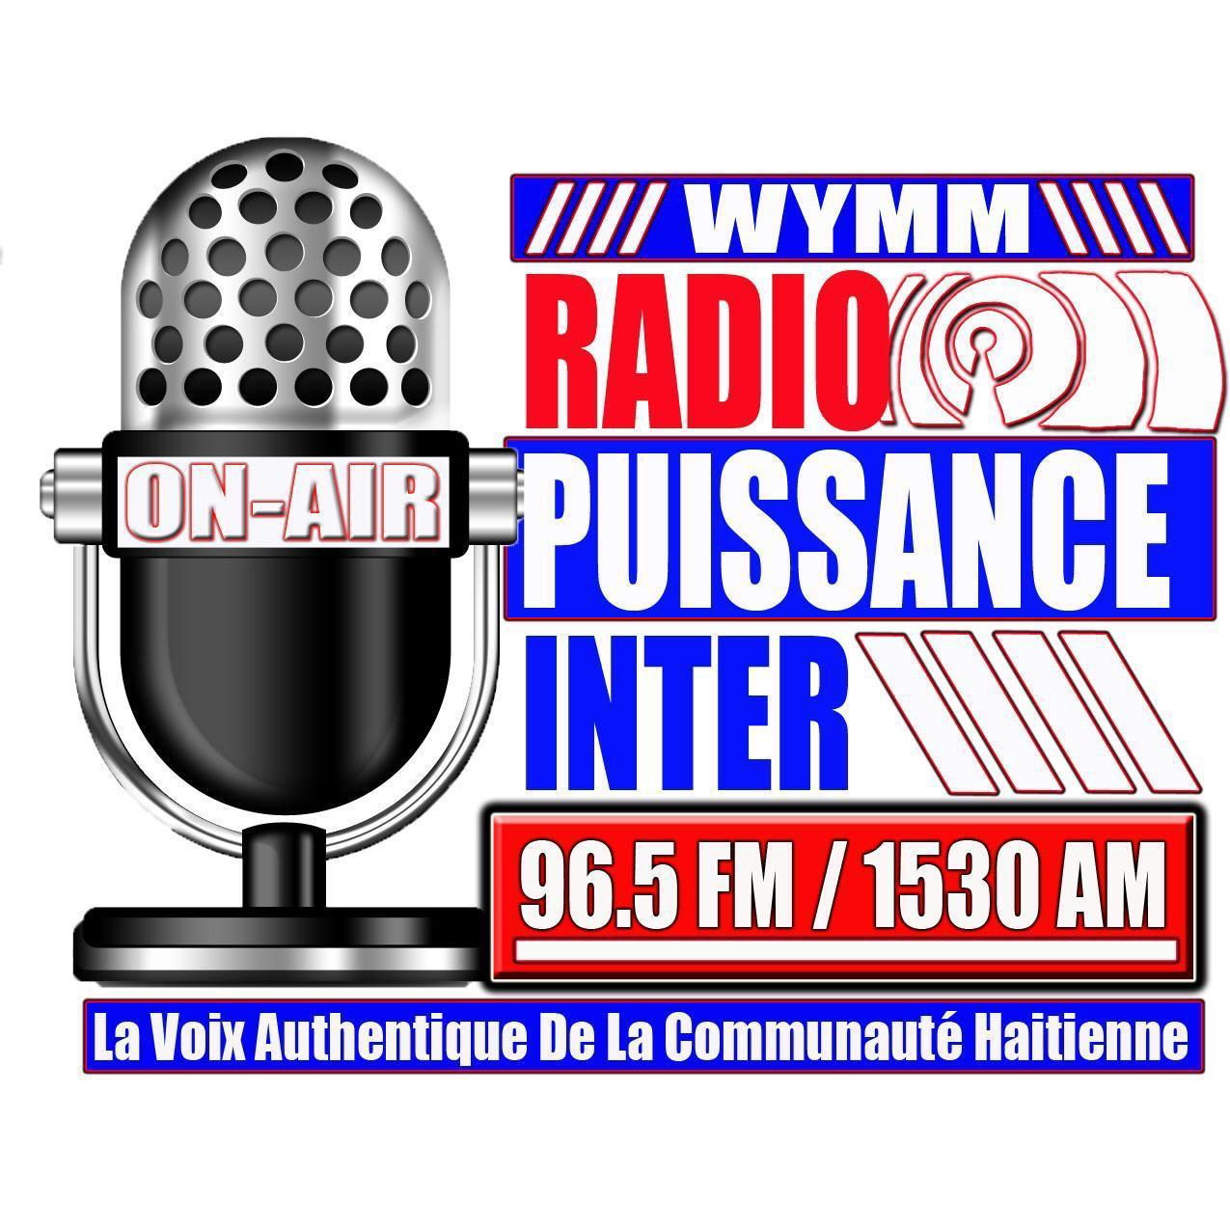

WYMM is a listeners supported radio station. your show, _______________ will be broadcast every _______________, from ____to _______ Pm. You monthly payment will be ________ is required by the fifth (5th) of each month. Failure to meet Radio Puissance Inter guidelines will result in a WYMM board staff to replace your air time show with another program following with an early cancellation fee of $400 for each remaining month. If there are any questions, comments, or concerns please feel free contact us at 904-786-2820.
RPI

First and Last name: _____________________________________________________
Signature: ____________________________________ Date__________________

