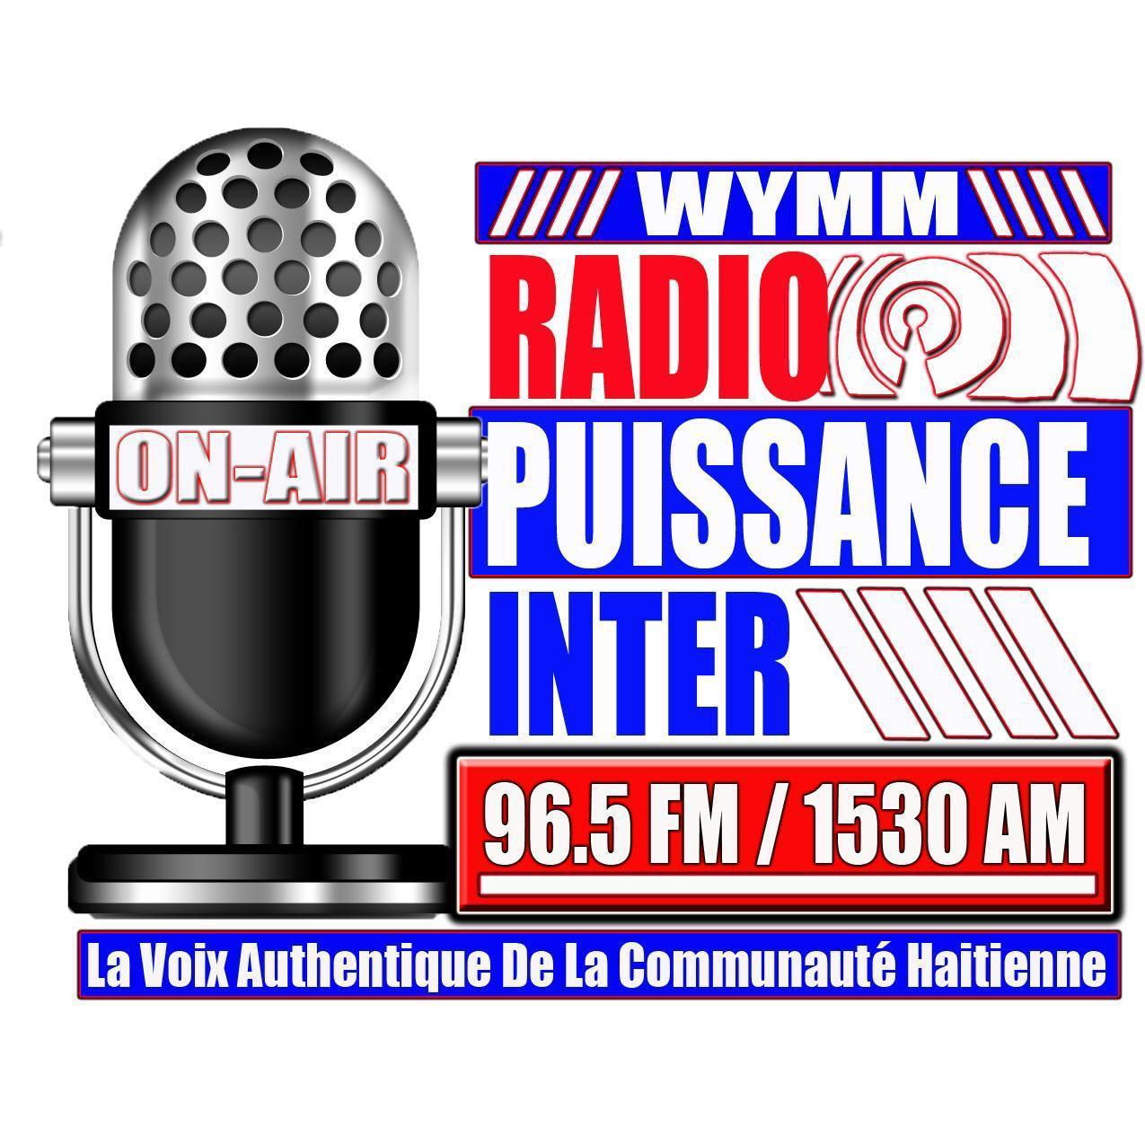

Airtime Agreement

This agreement is between AVM Broadcasting, airing on 96.5 FM/1530 AM, located at 5900 Pickettville Rd, Jacksonville Florida 32254 and ____________________, located at _______________, represented by ___________________.

AVM Broadcasting and _____________ hereby enter into a formal business relationship whereby client agrees to purchase Airtime on WYMM 96.5 FM/1530 AM, pursuant to the entire terms of this agreement.

Agreement Term
This agreement will be effective on ___________ for a period of __ month.
Pricing and Payment
Client agrees to pay the monthly airing cost of $ for ___ hours a week. If client desires to extend its programming, then the corresponding airtime cost will be applied.

Services Provided
Both Parties agree that client will be airing hours per week, which will be as describe above.
Days | Hours | Total of Hours Per Days
Sunday
Monday
Tuesday
Wednesday
Thursday
Friday
Saturday
Total per week |  | Hours
Total Per Month |  | Hours
Payment can be made in cash, check or credit card.

_____________________Date ___________________
Client

____________________Date ____________________
AVM Broadcasting

